In this assignment, I will cover the implementation of

Zuul mapping and routing service, using two additional services:

1. Organization-New – to differ between the two organization when routing.
2. Special Routes – to support different request routing between services.

Most of the implementation during this assignment will be through re-configuring the application.yml of the Zuul project. Through different executions, the request will be routed to either “old” or “new” organization services, using the Special Routes service.

Running mvn clean package docker:build :

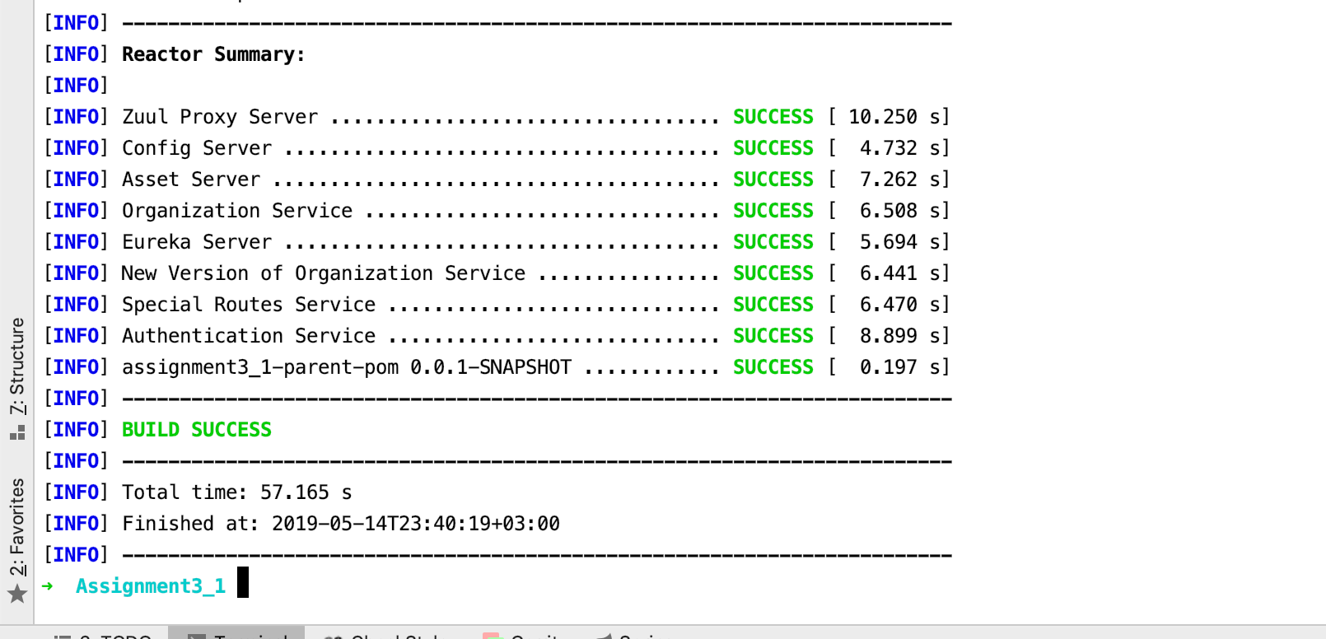

**docker-compose -f docker/common/docker-compose.yml up**

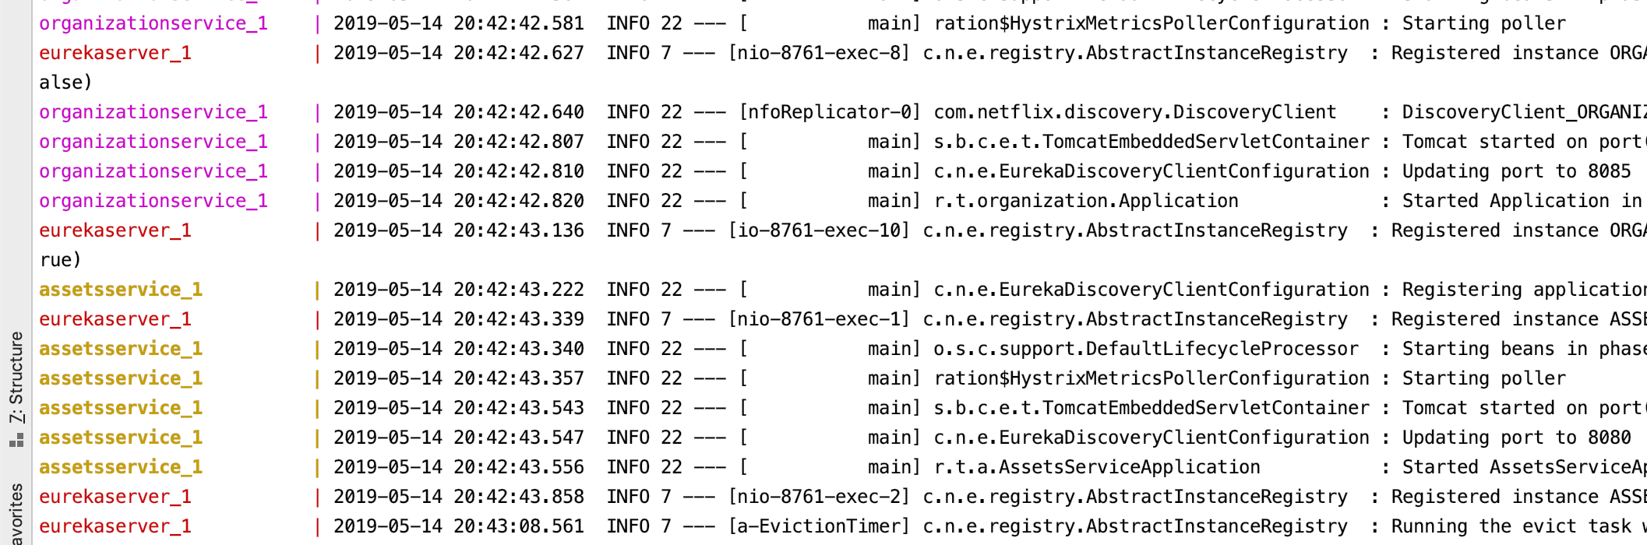

Use Case 1 – Access is restricted only to authenticated users:

Attempting to get organization details without authenticating.

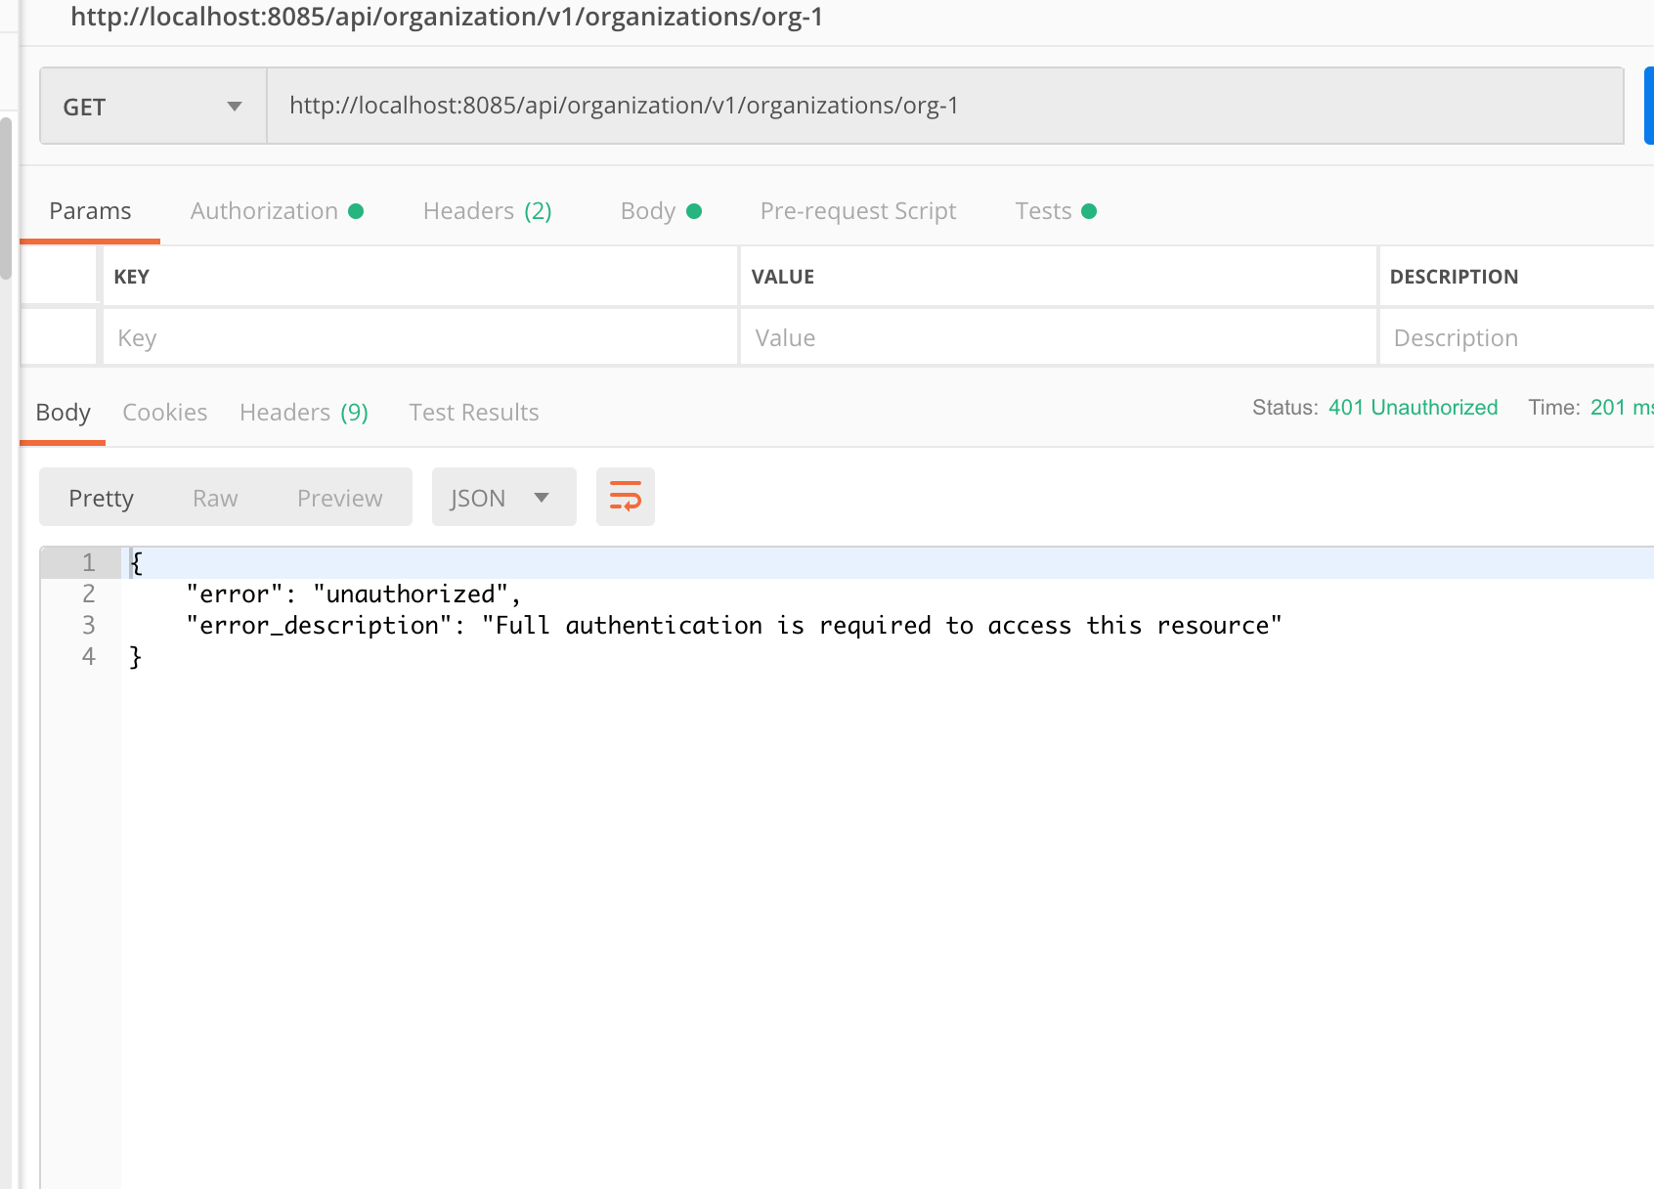

Attempting to get token.

Introducing username, password, grant type and scope to the body.

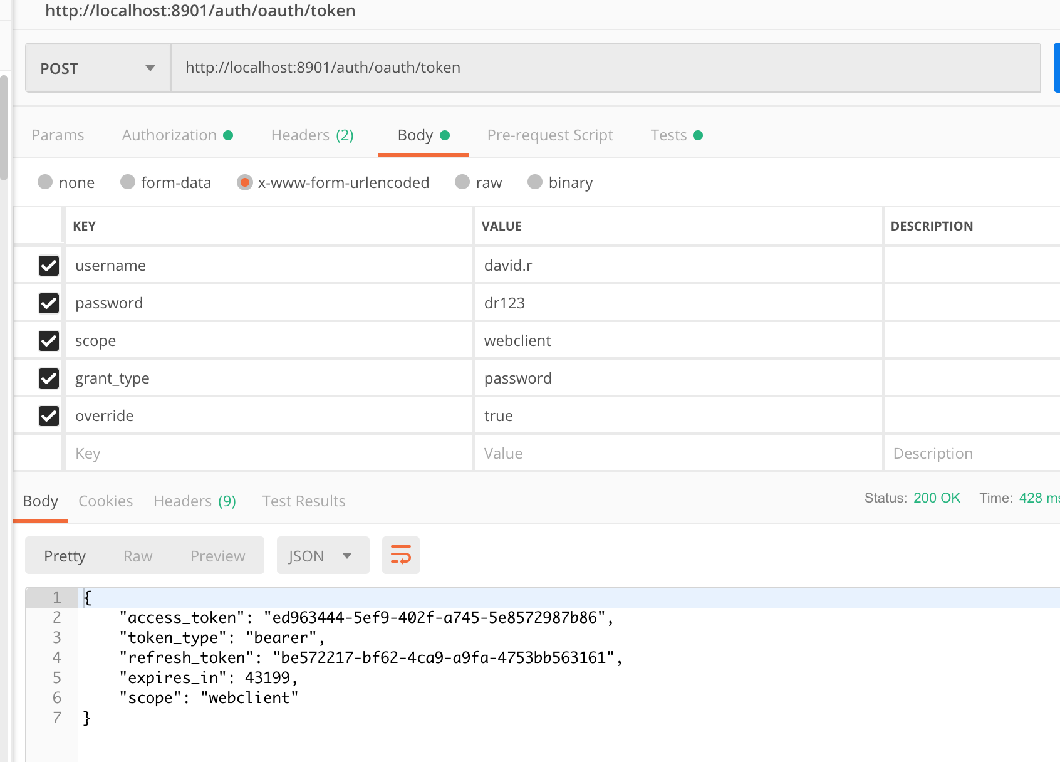

Setting authentication for getting token using username and password basic authentication:

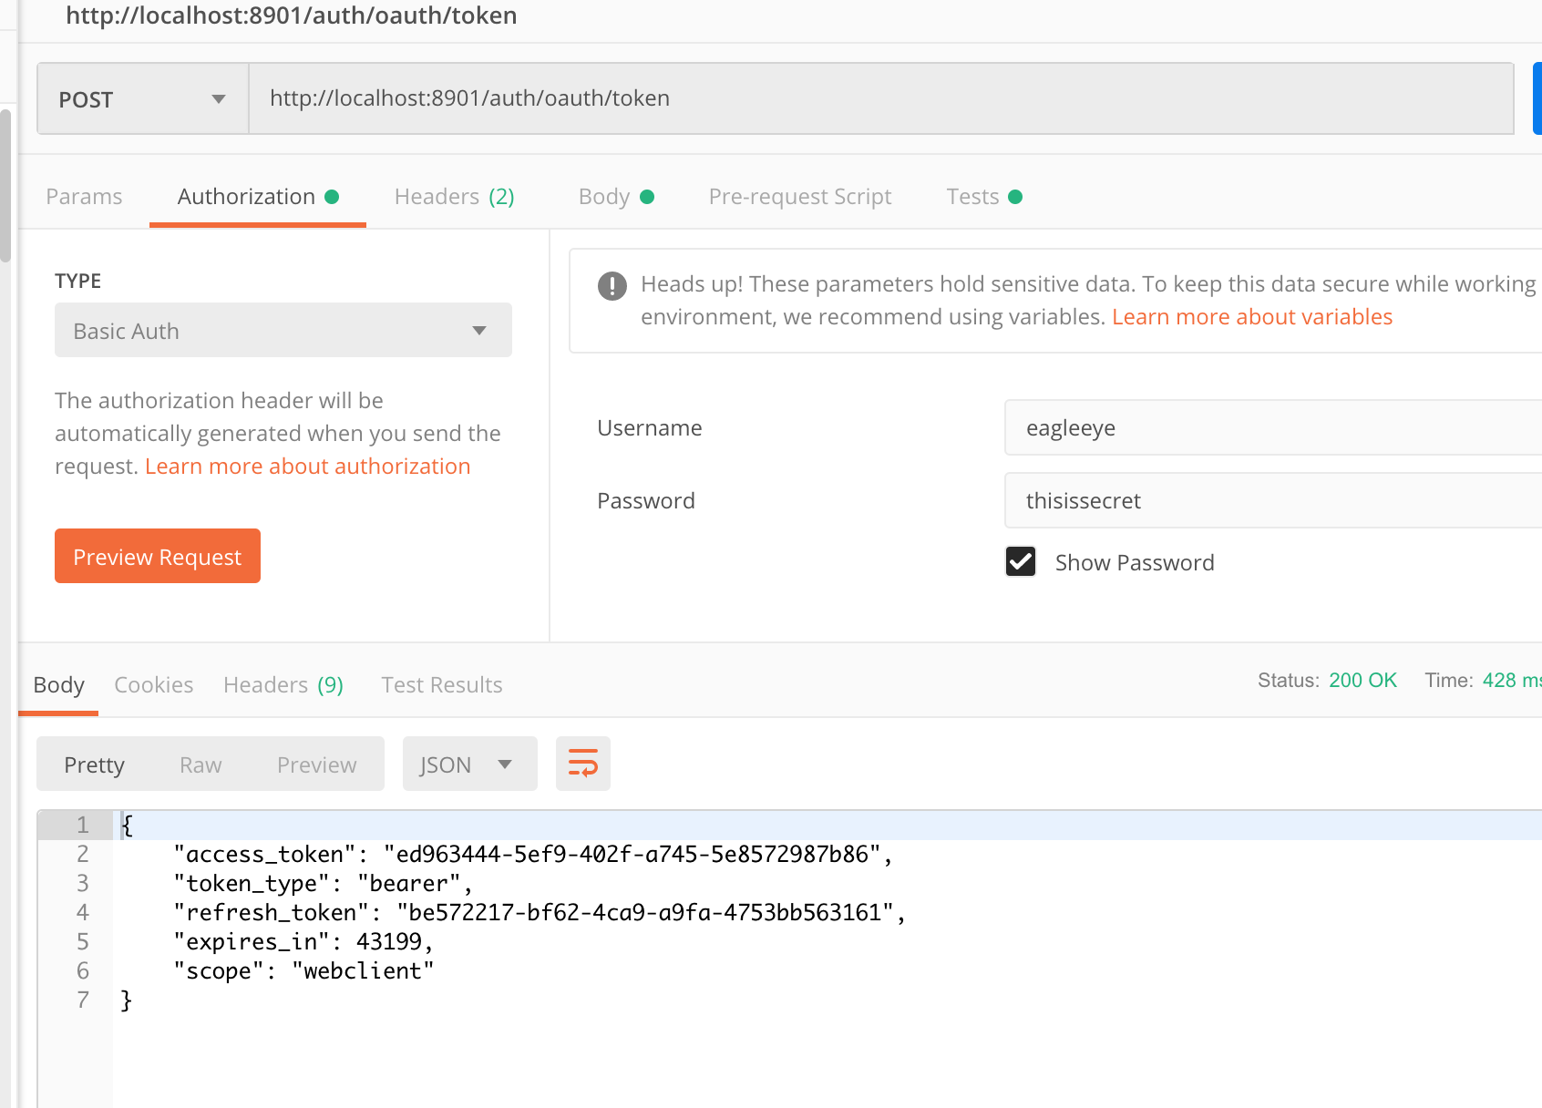

Introducing a script to referesh token :

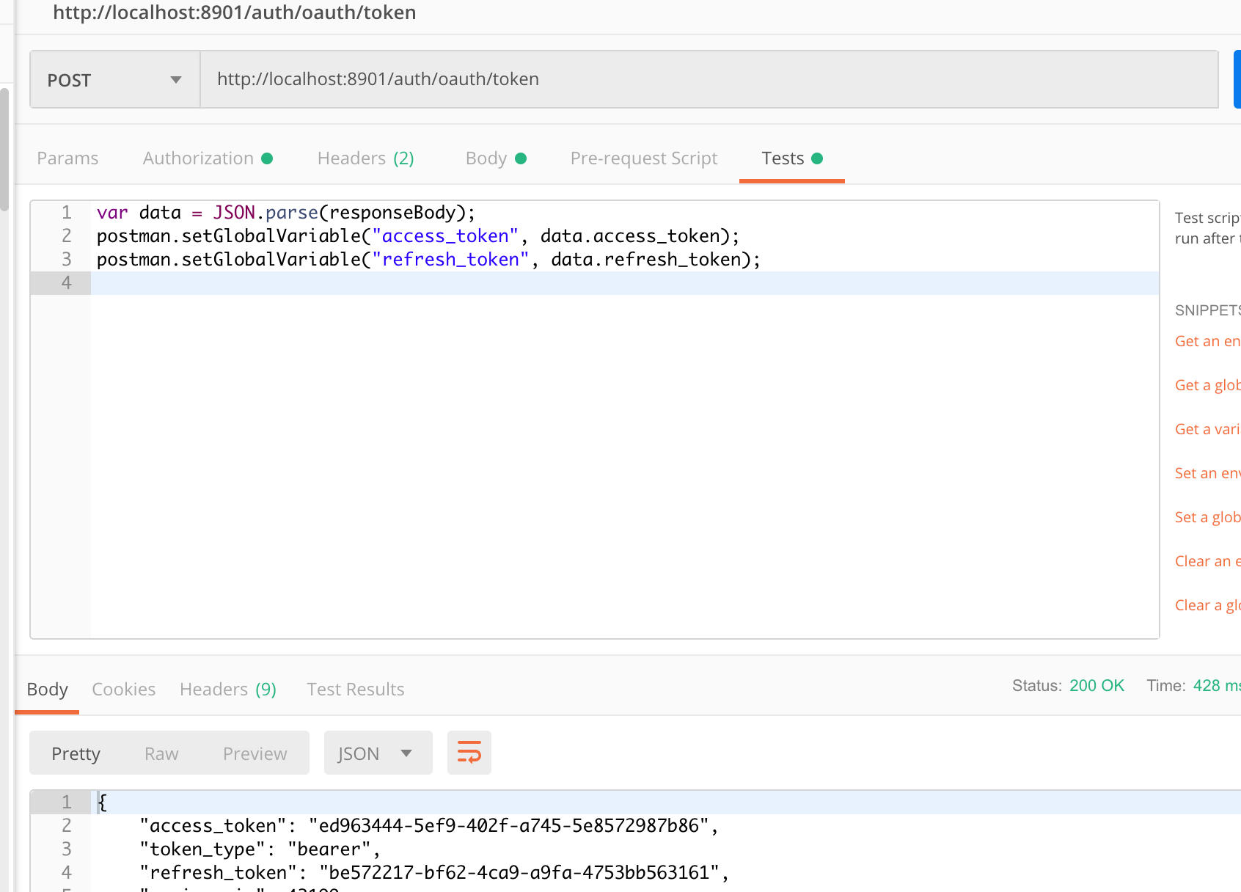

Getting organization with bearer token.

